Exercise 1: Implementing the Singleton Pattern

Main.java
public class Main {
public static void main(String[] args) {

System.out.println("Requesting Logger 1...");
Logger logger1 = Logger.getInstance();
logger1.logMessage("User logged in.");

System.out.println("\nRequesting Logger 2...");
Logger logger2 = Logger.getInstance();
logger2.logMessage("Data saved to database.");

System.out.println("\n--- Testing the Instances ---");
if (logger1 == logger2) {
System.out.println("SUCCESS: logger1 and logger2 are the exact same instance in memory!");
} else {
System.out.println("FAIL: They are different instances.");
}
}
}

Logger.java

public class Logger {

private static Logger instance;

private Logger() {
System.out.println("--- New Logger Instance Created ---");
}
public static Logger getInstance() {
if (instance == null) {
instance = new Logger();
}
return instance;
}

public void logMessage(String message) {
System.out.println("[LOG]: " + message);
}
}
OUTPUT

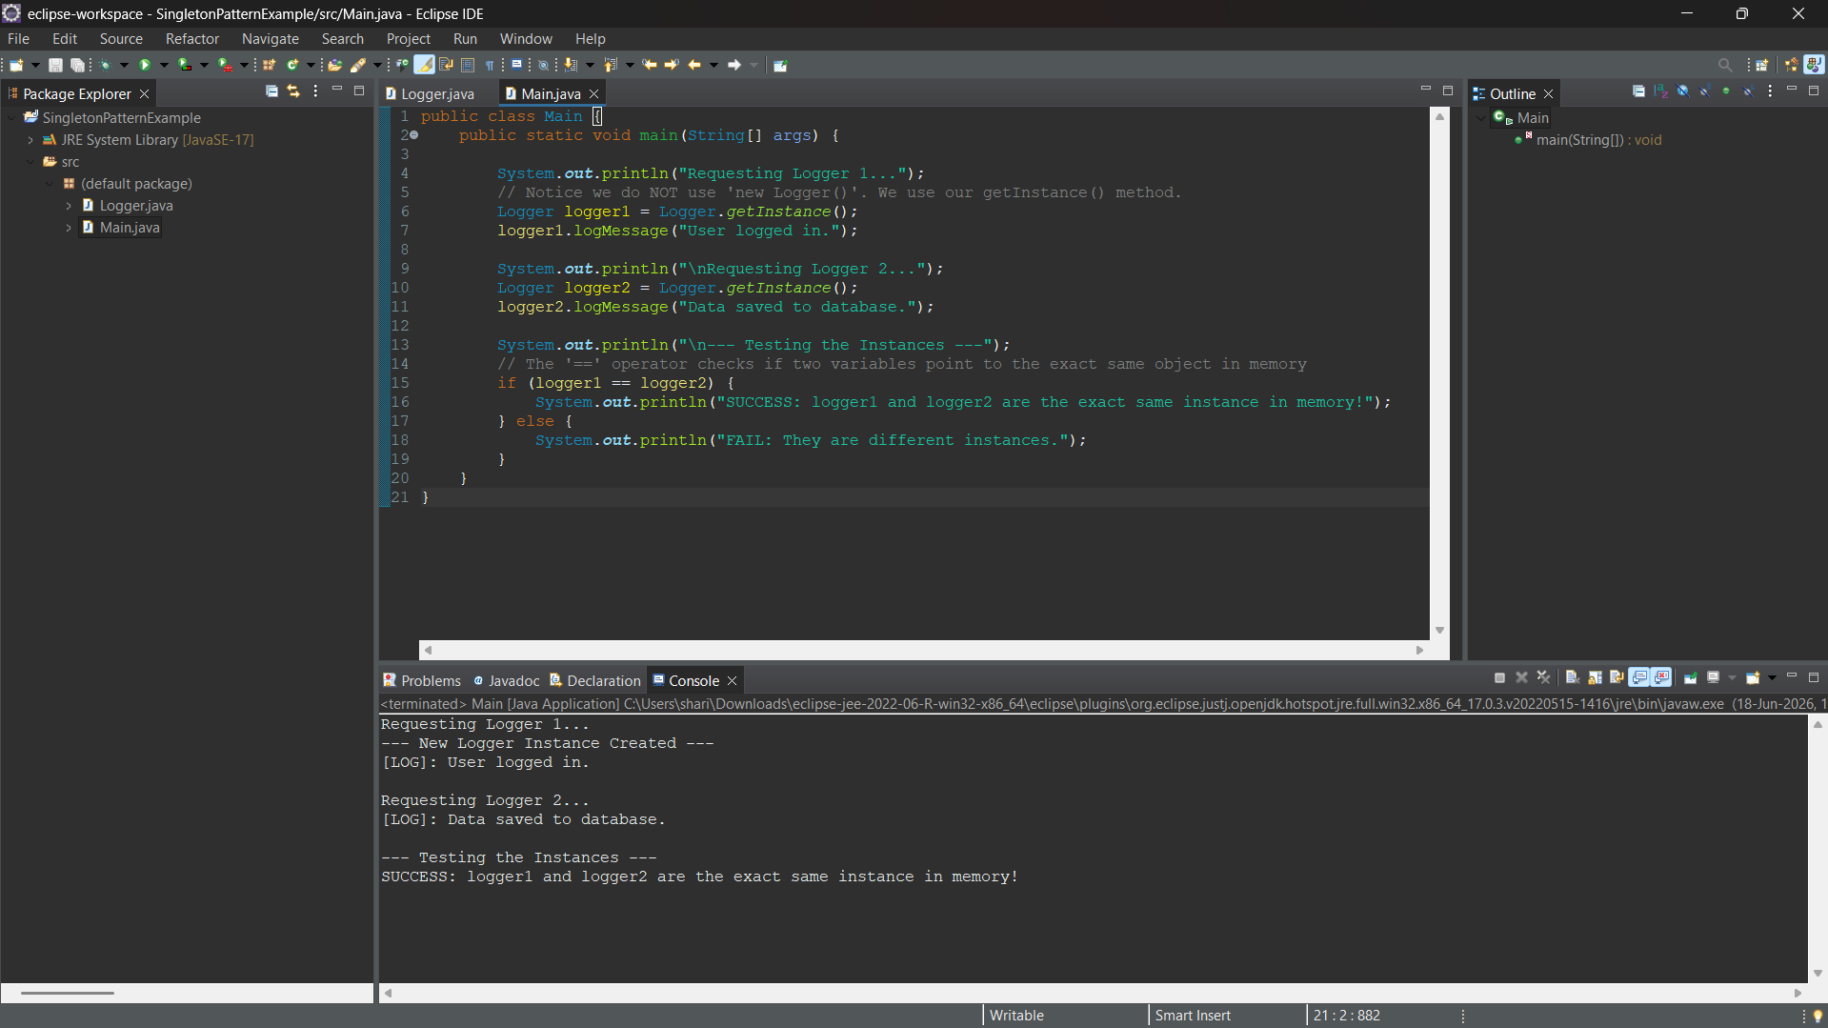

Exercise 2: Implementing the Factory Method Pattern

Output

